Application for Academic Guidance and Approval Form

Date:
Hiroshima University
Executive Vice President(Community Collaboration, Funding and Alumni Associations)

Applicant
Name:
Address:
Representative:

Applicant accepts the “Rules for Conditions of Academic Guidance” on the back and apply for academic guidance as follows.

Topic of Academic Guidance
Purpose and Outline | Purpose：
 | Outline：
Term of Academic Guidance  （Number of Hours） | Start Date: Finish Date:  （ hours）
Fee (JPY) | Japanese Yen
Supervisor at Hiroshima University | Affiliation:  Title:  Name:
Coordinator | Name:
Contact Information for Applicant | Department:  Name:  Tel:  E-Mail:
Notes (Special Conditions, etc.)

（ To be filled out by the University）
Approval  by Authorized Signer | Supervisor
Supervisor (Affiliation)
Name:
University Phone Number:
E-mail:
Hiroshima University approves the above application for academic guidance.
Date:
TO:

Hiroshima University
Executive Vice President
(Community Collaboration, Funding and Alumni Associations)

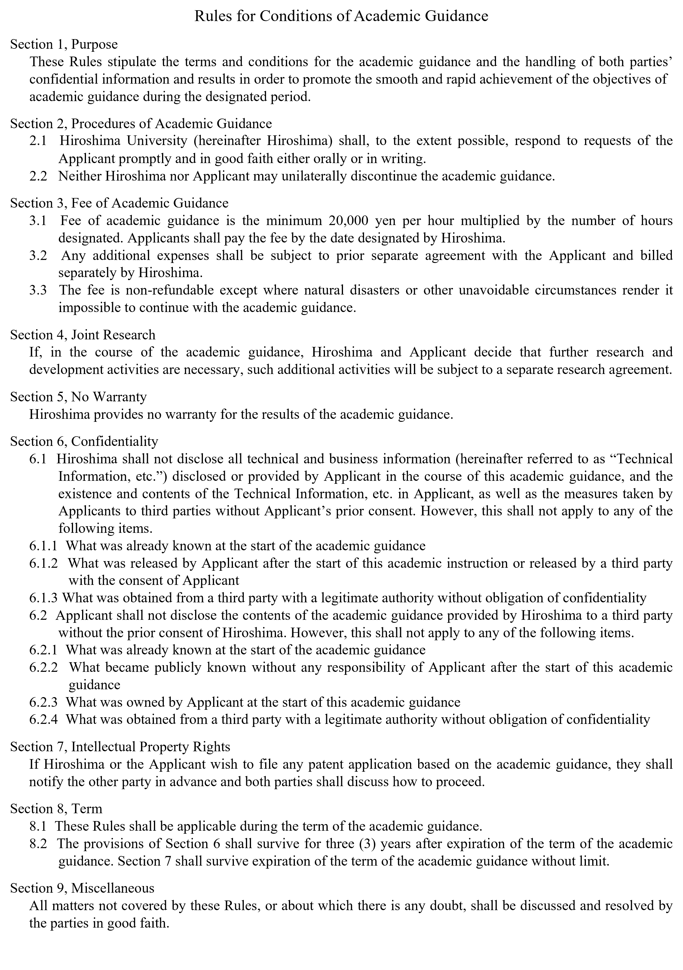

※Contact for Notices and Billing

※ Payment of the Fee of Academic Guidance shall be made by the end of the following month the invoice is issued.

Name:

Address:

Phone:

